**Lesson 7 Demo 2**

**Plotting Pie charts on a Map**

**Business Scenario:**

Eva Rodger, a sales manager, needs to analyze the sales generated by the states that are not doing as expected. This will help her improve the sales strategies. For this, she needs to create a map visualization with pie charts, which will display the percent to the total contribution of sales of each segment across all regions.

* Which state has the highest percentage of contribution of sales?
* What is New York’s Profit Ratio for the Corporate segment?

**Overview:**

* Create a filled map with State dimension and Color it by Region
* Create a dual axis map
* Change the second map to a symbol map
* Size the Marks by Percent contribution of Sales, and Color by Segment
* Change the mark type to Pie

The result should resemble the image given below:

**Detailed Instructions:**

1. Open **Tableau 10** (You can go to Start Menu -> All Programs -> Tableau )
2. Chart

   Description automatically generated with medium confidence On the home page, under **Connect**, under **To a file**, click **Microsoft Excel**.

Browse and connect to the **Sample - Superstore** Excel file

(NOTE: Provided in assisted practice)

1. Drag and drop **Orders** table to the canvas area

1. Create a filled map with the **State** dimension and add **Country** dimension in the **Detail** shelf

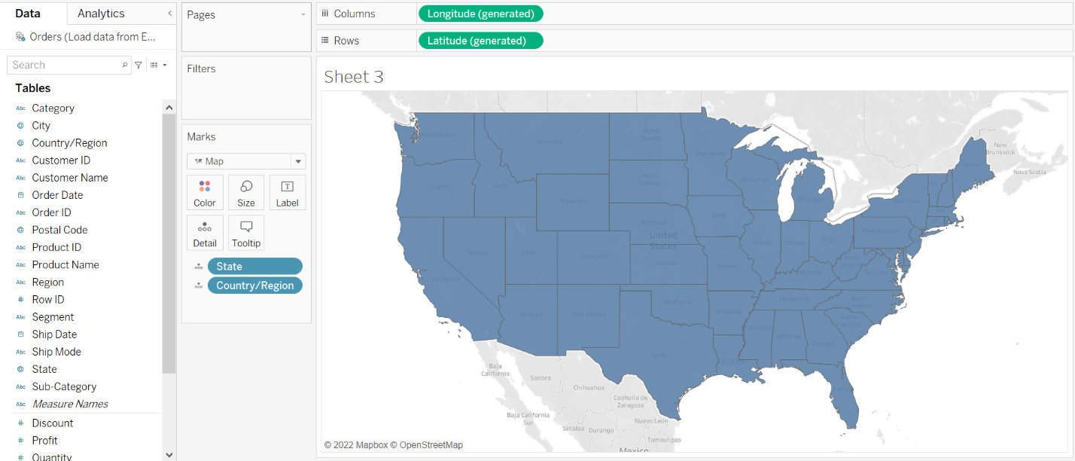

1. Drag the **Region** to the **Color** shelf

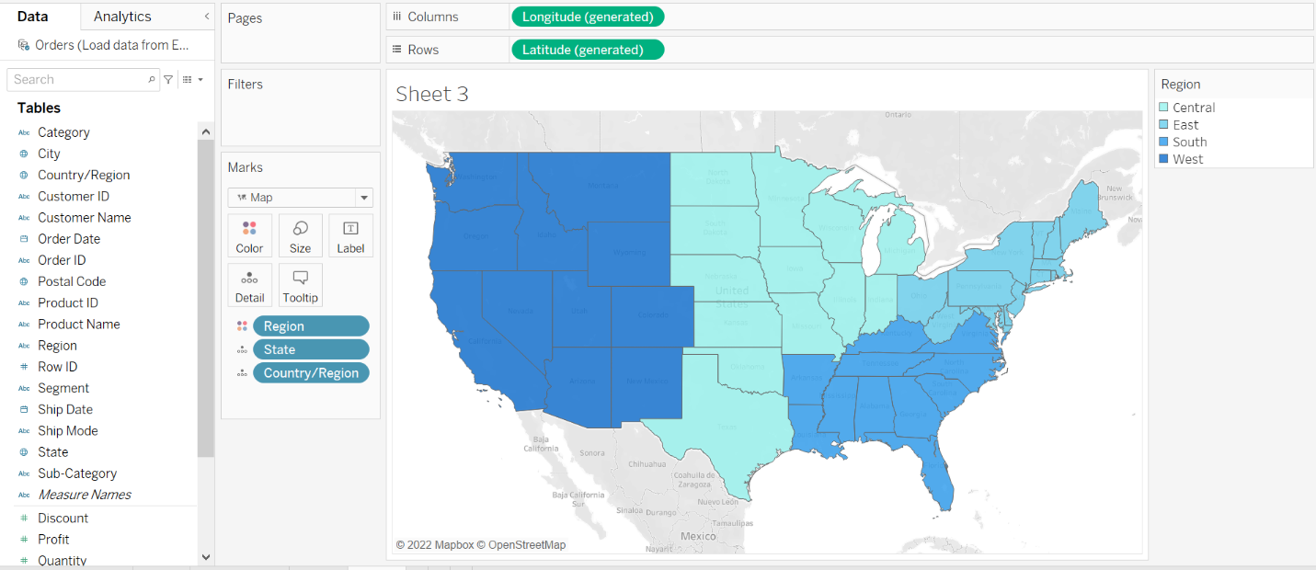 

1. Drag another instance of **Latitude (generated)** to the **Rows** shelf

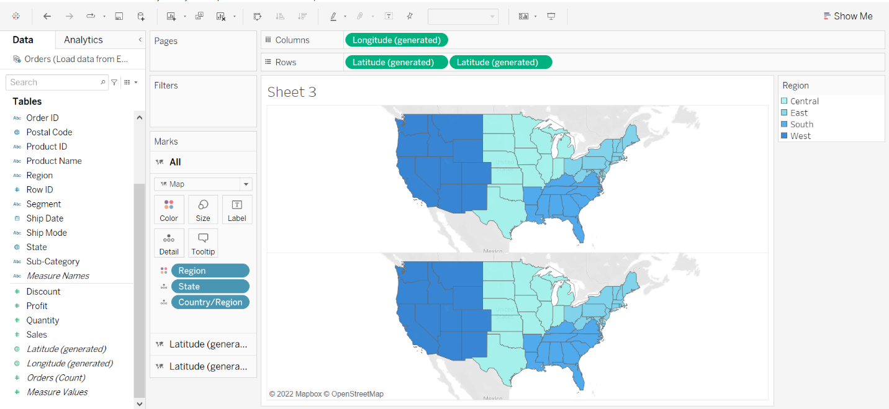

1. Under the Marks card for the second **Latitude (generated)**, select the **Mark Type** as **Pie**

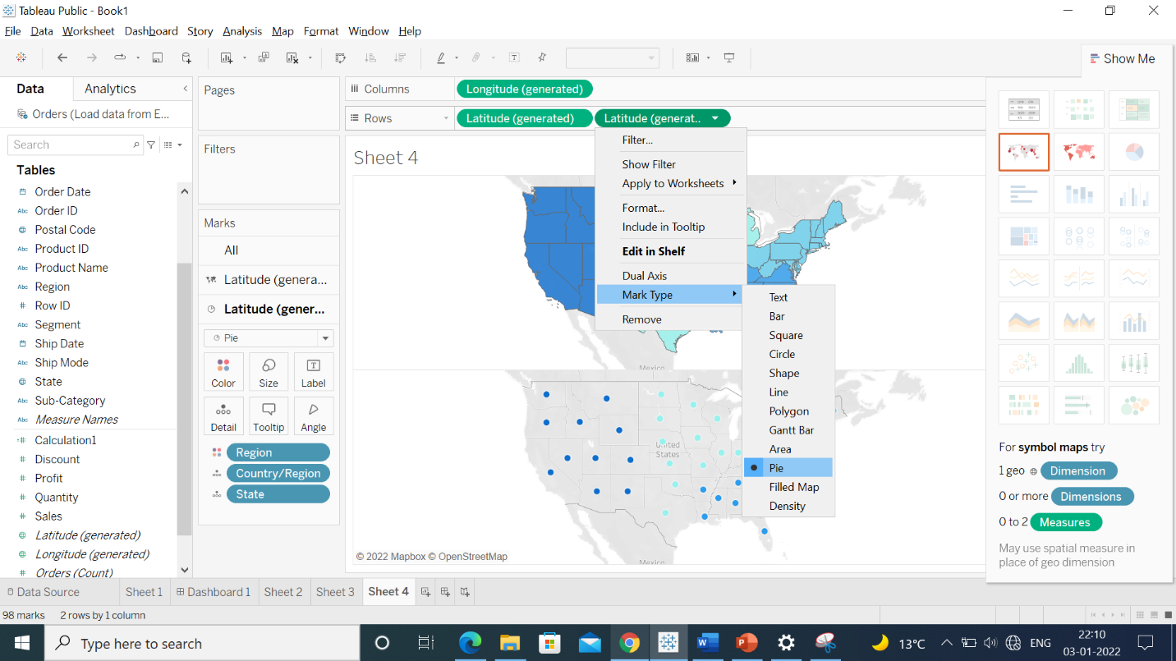 

1. Drag the **Segment** dimension to the **Color** shelf and the **Sales** measure to the **Size** shelf

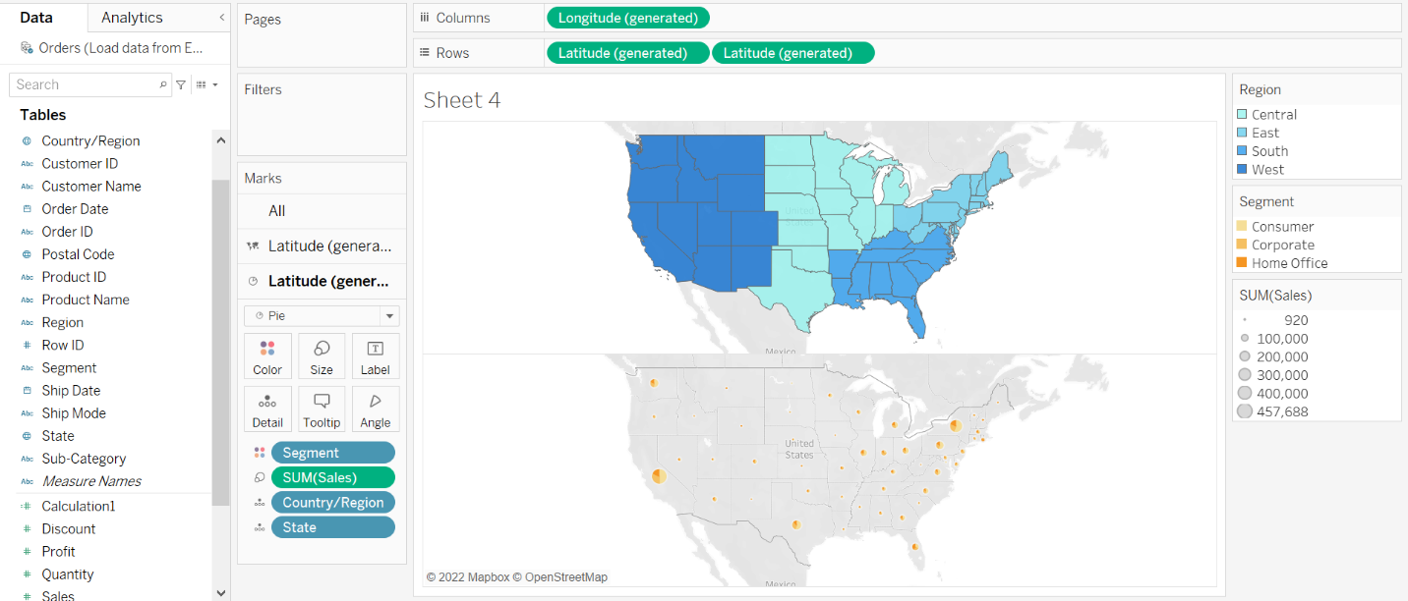 

1. To show the percentage of contribution of sales, right-click the **Sales** measure in the **Marks** card and select **Quick Table Calculation > Percent of Total**

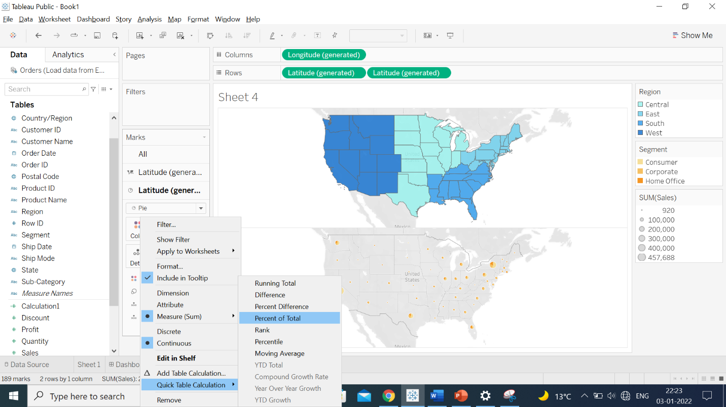 

1. Right-click the second **Latitude (generated)** pill in the **Rows** shelf and select **Dual Axis**

Note: You can change the color according to your preference.

Based on the view, these are the answers to the questions in the problem statement:

* Which state has the highest percentage of contribution of Sales?

Answer: **California**

* What is New York’s Profit ratio for the Corporate segment?

Answer: **17**